**ASSIGNMENT – 4**

**NAME –** PEEYUSH PAL SINGH

**SAP ID –** 500083838

**BATCH –** 5

**Q1. Write a program to accept three digits (i.e., 0 - 9) and print all its possible combinations. (For example if the three digits are 1, 2, 3 than all possible combinations are : 123, 132,321)**

**CODE:**

class combination

{

public static void main(String[] args)

{

int[] input = { 2, 4, 6 };

for (int x = 0; x < 3; x++)

{

for (int y = 0; y < 3; y++)

{

for (int z = 0; z < 3; z++)

{

if (x != y && y != z && z != x)

{

System.out.println(input[x] + "" + input[y] + "" + input[z]);

}

}

}

}

}

}

**OUTPUT:**

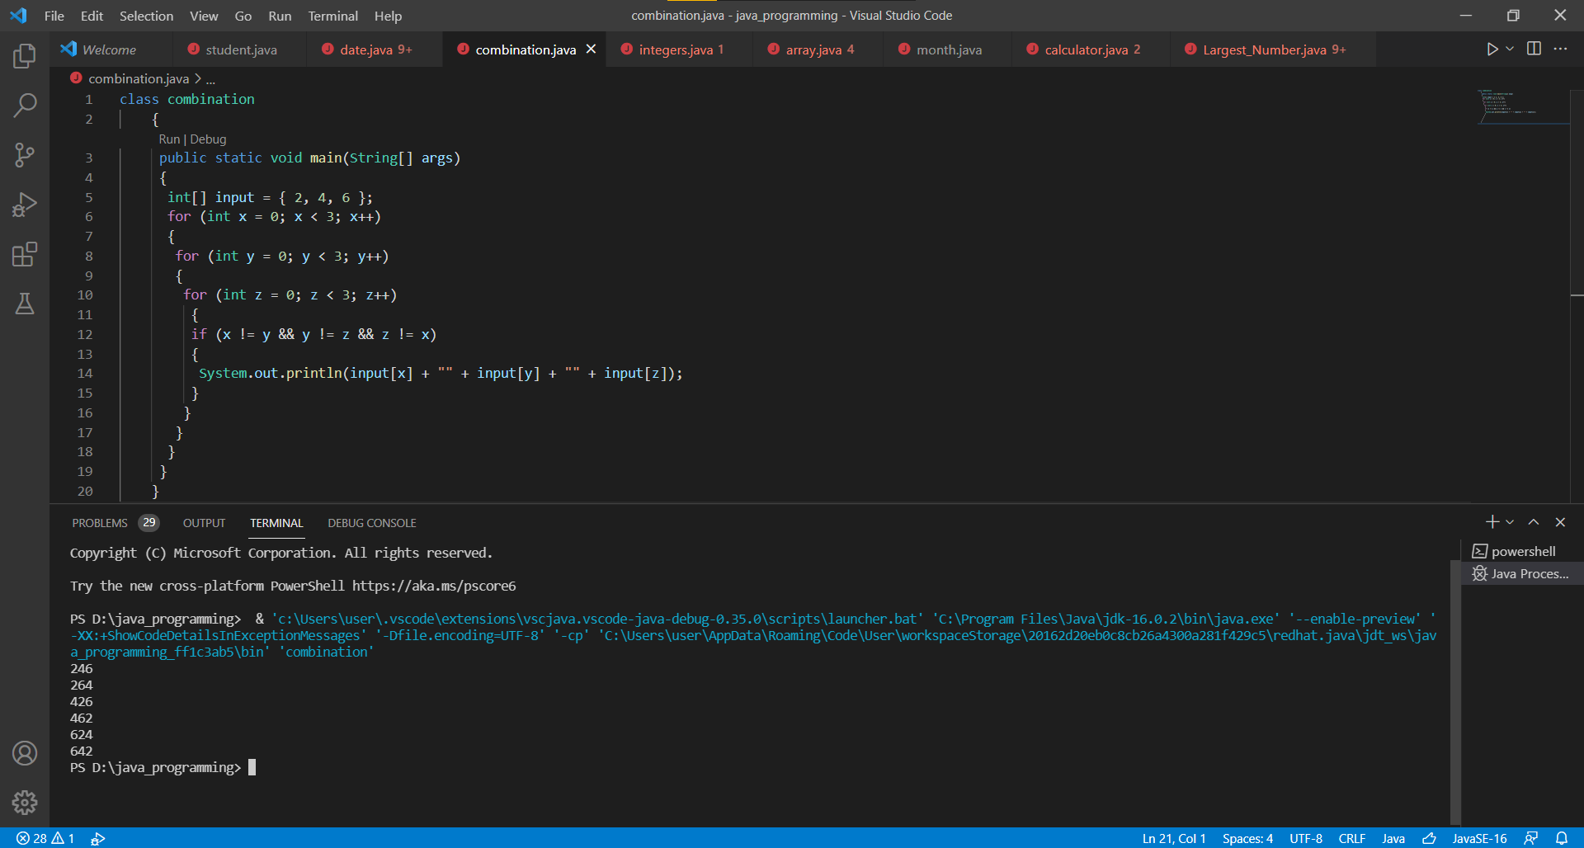

**Q2. Write a Java Program to accept 10 numbers in an array and compute the square of each number. Print the sum of these numbers.**

**CODE:**

import java.util.*;

class array

{

public static void main(String[] args)

{

Scanner input=new Scanner(System.in);

System.out.println("Enter 10 numbers: ");

int num[]=new int[10];

int sq[]=new int[10];

int sum=0;

for(int i=0;i<num.length;i++)

{

num[i]=input.nextInt();

sq[i]=num[i]*num[i];

sum+=sq[i];

}

System.out.println("Sum of the square of numbers: "+sum);

}

}

**OUTPUT:**

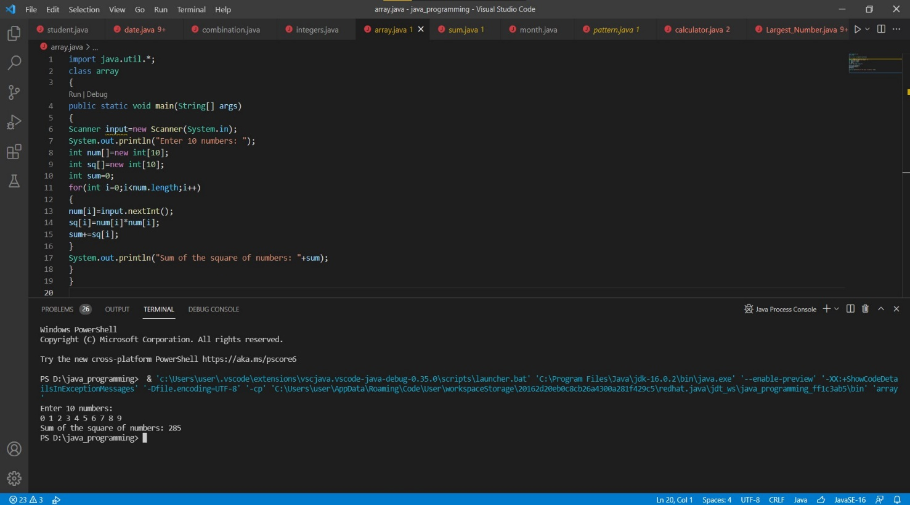

**Q3. Write a program to input a number of a month (1 - 12) and print its equivalent name of the month. ( e.g 1 to Jan, 2 to Feb. 12 to Dec.)**

**CODE:**

import java.util.Scanner;

class month

{

public static void main(String[] args)

{

Scanner mon= new Scanner(System.in);

System.out.print("Enter the number: ");

int month=mon.nextInt(); ;

System.out.println("---------------------------");

switch (month)

{

case 1:

System.out.println("The Selected month is: January ");

break;

case 2:

System.out.println("The Selected month is: February");

break;

case 3:

System.out.println("The Selected month is: March");

break;

case 4:

System.out.println("The Selected month is: April");

break;

case 5:

System.out.println("The Selected month is: May");

break;

case 6:

System.out.println("The Selected month is: June");

break;

case 7:

System.out.println("The Selected month is: July");

break;

case 8:

System.out.println("The Selected month is: August");

break;

case 9:

System.out.println("The Selected month is: September");

break;

case 10:

System.out.println("The Selected month is: October");

break;

case 11:

System.out.println("The Selected month is: November");

break;

case 12:

System.out.println("The Selected month is: December");

break;

default:

System.out.println("Please Enter a valid number");

}

}

}

**OUTPUT:**

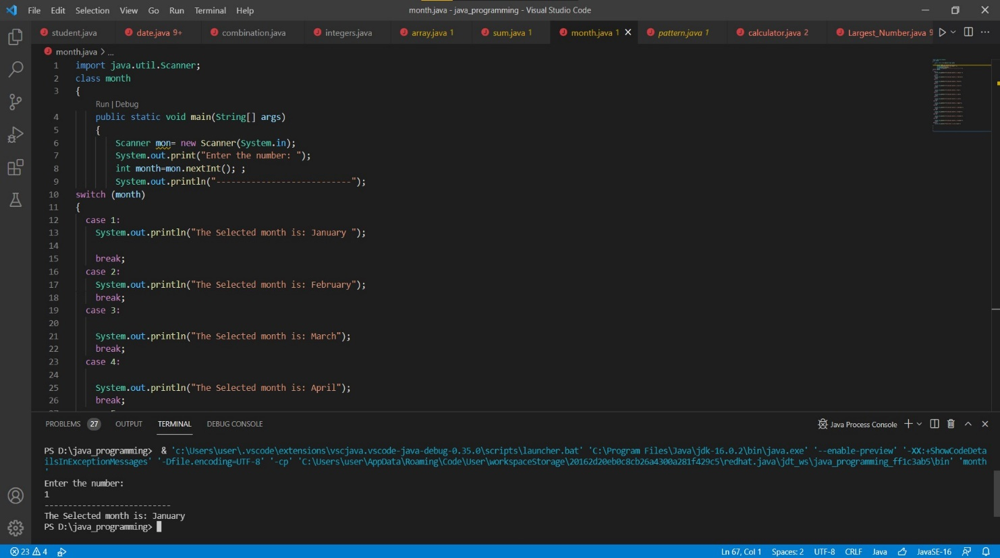

**Q4. Write a program to find the sum of all integers greater than 40 and less than 250 that are divisible by 5.**

**CODE:**

class integers

{

public static void main(String arg[])

{

int sum=0;

for(int i=41; i>40 && i<250; i++)

{

if(i%5==0)

{

System.out.println("The integers are: "+i);

sum=sum+i;

}

}

System.out.println("-------------------------------------------");

System.out.println("The sum of all integers is: "+sum);

System.out.println("-------------------------------------------");

}

}

**OUTPUT:**

